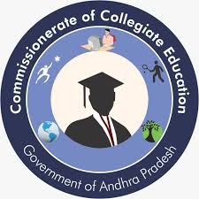**Govt. Degree College, Porumamilla**

**Dept. Of Commerce & Computer Applications**

**“Programmed on Financial Awareness and Education” on 31.10.2022**

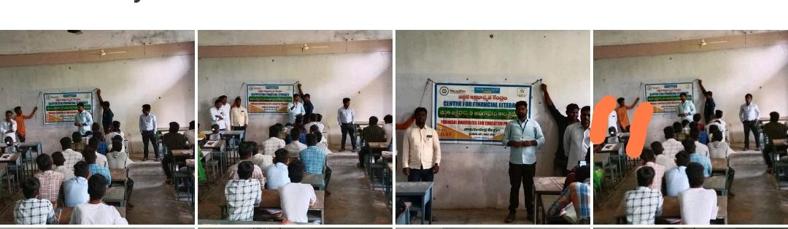

Department of Commerce and Computer Applications was conducted a awareness programmed on Financial Awareness and education with the collaboration of Canara Bank Center for Financial Literacy on 31.10.2022.

Representative of Canara Bank Center for Financial Literacy Senior Counsellor Y. Singaraiah addressed the students how precautions should take while using mobile banking or online banking transactions and also said that don't share OTP's or personnel details to unknown callers or messengers. and sensitized the students how financial frauds occurred if we unaware of financial literacy. All the faculty members and students involved in this programme.

